TORNNTTEANCHEA ZOMEACHE UGTAVNNECHEA MISAK SEVADHORM 2025
(LITURGY FOR THE YOUTH INAUGURAL MASS)

Vixoi: Tornnatteamno! bhorvanso amkam fottoinam!

Gaionank Suchna:
A-33 / B-10(vs 4) / C-34 / D-46 / F-10

Mirvonnuk:(Procession Activity) (optional)
Vhodd zolltea agttecho dhovo akar (Large shape of a flame in white) ani tache modem khursacho akar (shape of a cross at the centre of the flame), toiar korun Altara kuxik vo altara mukhar vo sogleanche nodrek dixtti poddtta tea ieukt zagear dovorcho. | 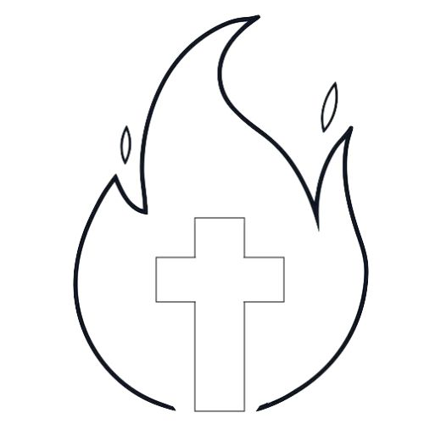
Hajir aslolea dor eka tornatteachea hatant, tanchem nanv borovun ek ujeachea rongachem kagdachem agttem diunchem. | 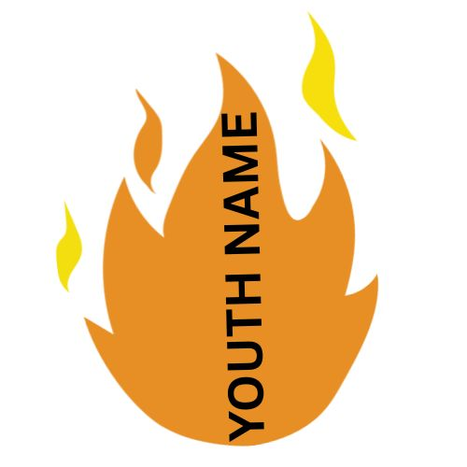
Mirvonnuken yetanam dor ek tornatto/tornattem aplem nanv mukhar dovorlolea vhoddlea dhovea agtteachea chitrar laitolim. Modlea khursachea akarak soddun lauchem. Soglleam tornatteanim aplea navachem agttem lailea uprant, ekuch vhodd Khursachem agttem toiar zata. | 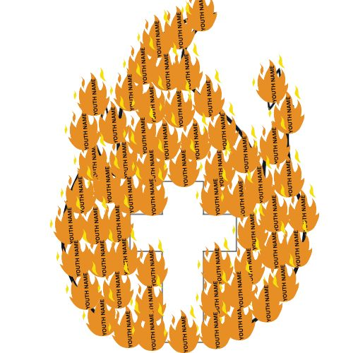

Survatechim Utram:
Mogachea Ixttamno, aiz ami kherit bhaxen amchea firgojent/kopelant Tornatteanchea Prexitayek (youth ministry) survat ditanv. Hea Don Hozar Ponchvis vorsak ami Utsov (Jubilee) somarombhtanv ani hea utsovik vorsant ami Tornatteanchoi Utsov (Jubilee of Youth) somarombhtanv. Amchea ________________________ firgoz/kopela tornatteancho zomo (Parish /Chapel Youth Group) amchea ________________ Varadd Tornnatteank (Deanery Youth) ek zata ani soglle ekunnis Varadd mellun Dhormprantik mollar Tornatteanchem Kendr (Diocesan Youth Centre) borabor povitr sobhent tornatteam pasot zaito boro vavr kortat.
Hea Don Hozar Ponchvis (2025) Utsovik Vorsak, ontoraxtrik mollar tornatteank prerna ditana sorgest pap saib Francis, Izaias provadiachea pustokantlim him utram gheun sangta, “Sorvesporacher visvas thevtat tim… dhanvtit khorem punn thokchim nant” hatuntlean tornatteachea kallzani bhorvanxeachem kirnn utpon korun tanchem jivit Kristi xegunnamni bhorunk huskaila. Aiz amchea tornatteanchea jivitachi poristithi niraxiponnan bhorlea, zoim zhogddim, rag-dves, onit ani ot’teachar, hanka dispott’ti fuddo korcho podd’dtana tim thoktat. Osle poristithint tannim “bhorvamnso amkam fottoina” him bhagivont Paulochim utram monan dhorun, Jezu sangatha bhorvanxeacho uzo aplea kallzamni pettounk tankam Bapachi kurpa hea Misa bolidanant magum-ia.
Prachitachi Rit:
Pettloleo Vati: (thoddea tornatteanim pettloleo vati gheun altara mukhar ubim ravchim)
“Hanv sonvsaracho uzvadd” him Jezuchim utram amchea kallokhi jivitant hea vatim porim uzvadd haddtta. Punn, mhojea jivitant borem-vaitt ghoddta tedna mhojem mon havem niraxiponnan bhorlam, ani bhorvanso soddun dila. Jezucho uzvadd mhojea jivitantlo paloila (hanga pettloleo vati paluncheo ani il’lo vell ogemponn samballchem). Jezuk man’ta te bhaxen nhoi punn mhaka zai te porim mhojem jivit jielam. Jezuk! mhojea jivitacho uzvadd korunk na. Amkam bhogos saiba.
Somia kakut kor! Krista kakut kor! Somia kakut kor!

Bhavarteanchem Magnnem:

- Amchea Pap Saib Leo, soglea bispamnim ani mottvaxeamnim aplem jivit Jezuk manovtolem korunk ani he toren Jezuchea bhorvanxeache nomunne zaunk, nhoich aplea utramnim punn odik korun aplea borea jivitantlean bhorvanxeacho uzvadd zaunk Bapacho adar tankam magum-ia
- Amchem rajkaronn choloitolea monxamnim aple porjeche huske aple korunk ani he toren Jezu bhaxen seve-chakreche mon apnaun, hatunt ki Bapachi khuxi asa, hem sot ollkun gheunk tanche pasot bhorvanxean magum-ia.
- Amchea Goy-Damaochea, Diocesan Youth Centre-achea sangatha vavurtolea dor eka firgojechea tornatteanchea zomeant toxench ekunnis varaddant vavurtolea tornatteam pasot magum-ia, Bapachi kurpa tanchea sangatha ani tanchea vavrant asunk magum-ia.
- Amchea _______________________________ firgojechea tornnatteanim amchea gonvllea _______________________ sangatha gheun, Jezuk aplea khasgi jivitant onnbhovun, bhorvanxeachim munxam zaunk Bapacho adar amkam magum-ia.

Bhasavnni
Mogalla Jezu! / Amchem tornattponn / Tujem ek / kherit dennem amkam. / Hea tornnea jivitant / zaiti tank (potential) / Tunvem amkam / favo kelea. / Amche avoi-bapui, / bhav-bhoinn, / ixttam vorvim / zaiti khuxalkai / amkam favo kelea. / Amchea zolm disa thaun / aiz porian / amchi ekan-ek / jivitachi ghoddi / Tujem vhodd / dennem amkam. / Jezu, / hea novea vorsant, / sogllea Tujea / boreponna khatir / Tuje upkar attoitanam, / teach borobor, / amche koxtt, / adkholli, teag, / amchim sopnam / ami Tuje / adin kortanv. / Amkam dil’lea / dennea vorvim / Tujea molleant / bore vavradi zaun / bhagivontponnan, / khuxalkayen, / udar monan, / ekcharan / subham follam diunk / ami anvdetanv. / Jezu, / hea amchea kariant / Tuzo sangat / amkam di / ani hea akh’khea vorsant / amchea vhoddilam khall, / eka-mekachea sohokaran / Sorginchem Raj bandunk, / hoch amcho hetu zaum. / Amen!

PARISH YOUTH INAUGURAL LITURGY 2025

Theme: Youngsters! Hope does not Disappoint us!

Hymns: A.102(WJL) / N.24(WJL) / D.26(WJL) / I.24(WJL)

Procession Activity: (optional)
Prepare a large outline of a flame with an outline of a cross at the centre of the flame. Keep this on a stand near the Altar or a in a place where it will be visible to the whole congregation. It should be accessible to the youth who will be coming in procession for Mass.
Prepare a small flame shape with the name of the youth or it could be hand written by each youth before Mass.
Each Parish Youth will carry their name on a flame in the procession and place it or stick it within the outline of the large flame. The the centre area blank of the cross. All the small flames combined together will form one large flame with the cross at the centre.

Introduction:
Dear friends, today in a special way we mark the beginning of youth ministry in our Parish. This year is celebrated as the Jubilee Year 2025 and within this Jubilee Year we also celebrate the Jubilee of the Youth. Our __________________________________ Parish/Chapel Youth Group combines with our _______________ Deanery Youth and all the 19 Deaneries combine with the Diocesan Youth Centre to carry on the good work of youth ministry for the Church.
The late Pope Francis, while encouraging the youngsters at the international level, took up the words of prophet Isaiah, “but those who hope in the LORD… will run and not grow weary.” He called on young people to view life as a pilgrimage, urging them to embrace hope and perseverance through struggles. Today, lives of youngsters are filled with despair, where there is fighting, anger, injustice and persecution, they get tired and exhausted by it. In these circumstances they ought to remember the words of St. Paul, “hope does not disappoint us” and rise up with Jesus with a flame of hope in their hearts. Let us pray for this grace during this Eucharistic celebration.

Penitential Rite:
Burning Candles: (a few youth could stand in front of the Altar, each holding a burning candle)
“I Am the Light of the World” these words of Jesus brighten up the lives of youngsters who are experiencing darkness. But when these difficult moments enter our lives we end up focussing on our failures, leaving behind the only ray of hope: Jesus! and darkness has entered our lives (at this moment blow off the candles and observe a moment of silence). We have lived life our own way, not the way Jesus taught us. We have not made Jesus the light of our lives. For this, we ask pardon and mercy from the Lord!
Lord, have mercy! Christ, have mercy! Lord, have mercy!

Prayer of the Faithful:

- We pray for the clergy, that, our Pope Leo, all the bishops, priests and religious may live their lives in the footsteps of Jesus to be beacons of hope to the youngsters, through their words and deeds. For this we pray to the Lord!
- We pray for the political leaders, that, the elected leaders may reach down to the grassroots level to understand the real issues faced by the people and work with a heart filled with service towards making their lives better. For this we pray to the Lord!
- We pray for the youth ministry, that, every parish youth group combined with the youth of 19 deaneries join hands with the Diocesan Youth Centre to make youth ministry fruitful and filled with hope. For this we pray to the Lord!
- We pray for our own _____________________________ Parish Youth, that we along with our shepherd Fr. ___________________ may work together to experience Christ and to be a ray of hope to all those whom we encounter. For this we pray to the Lord!

pledge
Dear Jesus, / Our youthfulness / is your beautiful gift / to us all. / You have blessed us / with lots of potential. / Our parents, / siblings, / friends / and all our near and dear ones / only add up / to our joy of living. / From the time / of our conception / till this very day / Your guiding presence / has never left our side / for which / we are greatly / indebted to You. / Sweet Jesus, / as we thank you / for this new pastoral year, / we place before You / all our joys / and sorrows, / difficulties and challenges, /dreams and aspirations. / Bless us / in building bonds / of unity, / love and service, / thereby /growing in holiness / and glorifying / Your Holy name. / Guide us O Lord / and help us / to be obedient / to the authorities / and work together / zealously / in spreading / Your kingdom. / Amen!

